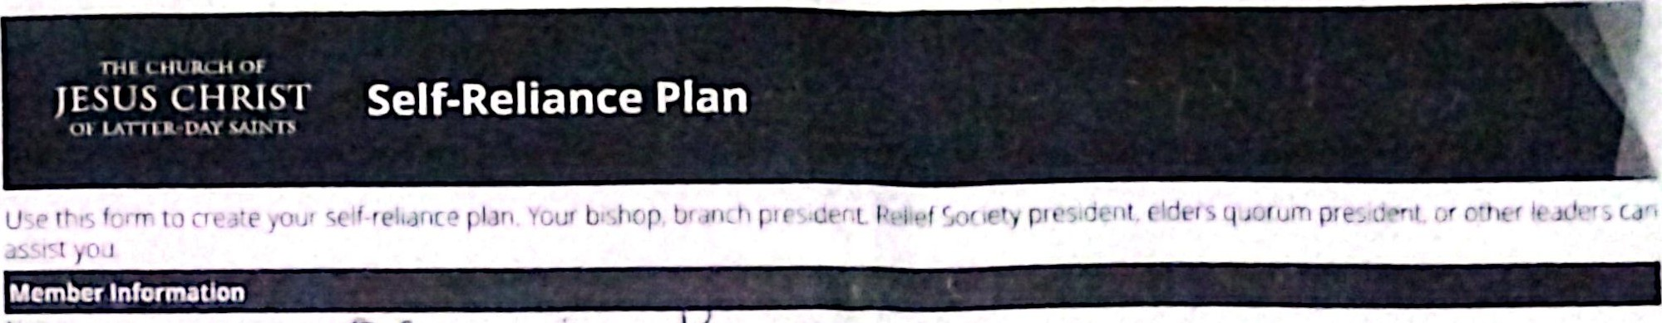

|  |  |
| --- | --- |
|  |  |
| Step t: What are my needs? | |

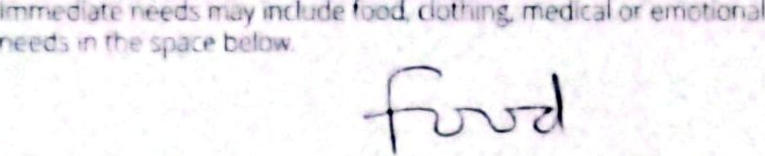are. cr hcu•ung Cdnnon cr



Monthty income

|  |  |  |
| --- | --- | --- |
| from household memoer% | |  |
| Other sources offers) | |  |
| (f,nancal, food. hotcrg. and so forth) | |  |
|  |  |  |
|

uonthfy expenses

|  |  |  |  |  |  |
| --- | --- | --- | --- | --- | --- |
| T tres cfien.ags | | coaJÄJ | | Deot |  |
| Food | |  | | clothing | 1 SOL |
| Heusr g | |  |  | Electnctty fuel |  |
|  | | 2 |  | (spec j |  |
|  | | 5 | |  |  |
| Transpoaotcn | |  | |  |  |
| E duotton | |  | |  |  |
|  |  | | | |  |

